Merrill RANKEN, MEd.

90 River Road, Wailuku, HI 96793 | merril.ranken@gmail.com| (808) 463-8378

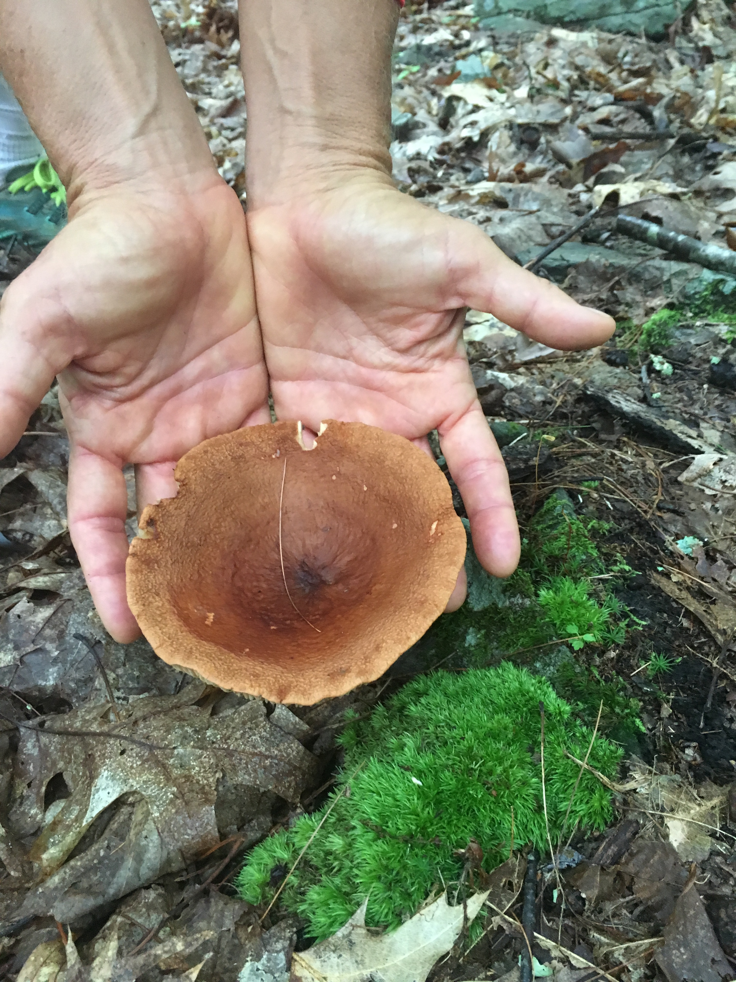
Professional Objective | Continually seeking opportunities to apply my extensive, 28+-yr., background delivering culturally responsive, nature-based science in both formal and informal settings. Problem-solving from a STEAM perspective, I bring an intention to both teach and learn with the natural environment as my inspiration and the cultural lens as my mentor. The ideal professional environment would allow me to develop and implement project-based, content-integrated science and outdoor education curriculum aligning with Hawaiian cultural content and values of sustainability with three-dimensional NGSS alignment.  I welcome participation in dynamic professional projects where creativity, team work and self-direction are honored and where my maturity and background as a mentor and trainer will enhance the professional performance and job satisfaction of my colleagues.
Skills & Abilities | Design project-based STEM curricula integrated with the arts, the ‘āina and advocacy.  Integrating Classroom Curricula with NGSS  Build frameworks for effective use of science notebooks as tool for building student-generated evidence-based claims and for formative assessment in the classroom.  Co-construct professional development opportunities with small and large groups to advance identified goals and establish a supportive culture for growth.  Facilitate learning through physical activity and play.
Experience | STEAM Teacher / Garden Learning  Pōmaika‘i Elementary School  November 2015 to present http://steammrsranken.weebly.com/  Coordiante w/ classroom teachers to Implement project-based engineering curriculum WITH OUTDOOR LEARNING for grade k-5 students  - Establish and manage professional relationships with classroom teachers to develop and teach project-based unit through the lens of place.  - Prepared an evidence-based report to school administration on current status of use of science notebooks at Pōmaika’i school.  - Develop and teach standards-based field science lessons for Pōmaika’i school students in grades 1-5 at Waihe’e Coastal Land Refuge as a part of on-going collaborative community partnership.  - Integrate teaching practice with culturally responsive and sustaining techniques to serve as a model and collaborator with other teaching staff.  - Coordinate garden lessons and use of garden as an outdoor learning environment; during instructional day and in afterschool programs.  Field Supervisor/Lecturer  UH Mānoa, College of Education  Statewide Teacher Education Program  August 2019 to present  - Directly supervise teacher candidates in their classroom placement over years 2-3 of their pre-service teacher preparation.  - Establish and facilitate Mentor Teacher relationships with Maui classroom teachers.  - Critique, observe, provide feedback and support development in all aspects of teaching practice. Lead monthly seminars in lesson planning, developing professional relationships and refining teaching practice according to the Charlotte Danielson Framework which is the DOE mandated assessment tool for classroom teachers.  Curriculum Re-Design and NGSS Alignment  Haleakala National Park  June – October 2014  - Align the NGSS (Next Generation Science Standards) with existing HNP interpretive themes.  - Evaluate existing Haleakala National Park curriculum and identify areas for revision  - Work with Park ranger partner and education program staff to draft revised grade 4/5 Geology and Hawaiian Studies curriculum, “Kulia I ka Nu’u . (Work product available provided upon request)  Sixth Grade Teacher (Science/Applied Math/Hawaiian)  Kihei Charter STEM Middle School Kihei Charter STEM Middle School  July 2013 to November 2014  Develop and Implement project-based field and classroom science program for 68 students integrated across cross-curricular disciplines and scaffold within the 6-8 middle school framework for science.  • Establish and manage relationships with community partners to facilitate authentic field science experiences while leveraging the unique mobility and responsiveness of the charter school model.  • Planned and implemented inaugural sixth grade Hō’ike program. This student-led project incorporated Hawaiian cultural values, language and practices with 21st Century learning skills and culminated in a student-directed sharing for family and community.  Director of Education Programs / President Sea Sport Cruises  Pacific Whale Foundation compensation: salary  2000-2005, 2006- May 2013  • Responsible for the direct supervision of middle-management of education and conservation departments to integrate functions in the areas of youth education, formal and informal interpretation programs, community outreach, special events. 30-40 direct reports within the organization, depending on season.  • Essential duties include: education program development and implementation for students, staff, supporters and community; integrated program and marketing for vessel-based education initiatives; intra and inter-departmental staff training and on-going professional development; create and review collateral materials for education and community outreach; represent PWF in the professional and local community.  • Significant contribution in development of marine science curriculum and experiential learning opportunities for lab, field, vessel setting for pre-school through high school.
Education | University of Hawaii, Mānoa, Honolulu, HI  MEd. Curriculum Studies, STEMS concentration; 2018 College of Education  Chaminade University, Honolulu, HI  BSc. Elementary Education, 1993  University and American Montessori Society, Honolulu, HI  Montessori Early Childhood Credential, 1993  Buckenell University, Lewisburg, PA  Biology , 1986-1988
Professional presentations | Fear Not- You can STEAM with Early Learners  Presentation to STEMS2 Symposium  UH Mānoa, College of Education June 2019  Starting with Questions- Building Student-Directed Learning  PD to Pōmaika’i Teachers and Staff Kahului, August 2018  Phenomenon Drives Inquiry- Starting with Discrepant Events  PD to Pōmaika’i Techers and Staff Kahului, October 2016  Juggling the Environmental, Social and Economic Benefits and Costs of a Green Event  College of Marine Ecotourism, University of Auckland, New Zealand 2012
Professional development | Buck Institute for Education, PBL Works  Design, assessment and management of a project-based learning unit. Developed a pilot unit for grade 3, “Ho’omalu- Creating Shade”- a student led project to address the design of effective shade structures to expand and enhance outdoor learning environments.  (21 hrs.) Maui Arts and Cultural Center: June 2020  Arts and Technology Summer Institute  Visual arts and technology to develop stop-motion animation stories as a demonstration of project-based learning.  (21 hrs.) Maui Arts and Cultural Center: June 2019  Teaching Students to Ask Their Own Questions- Exploring the Question Formulation Technique  Professional collaboration and dialog around Implementing the QFT and using students’ questions to advance teaching and learning goals.  (10 hrs.) Harvard School of Graduate Education and Right Question Institute: April, 2019  Kū ‘Āina Pā, School Garden Teacher Training Intensive  Establishing excellence in school garden practices with focus on implementation of Hawaii School Garden Curriculum Map.. (30 hrs.) Hawaii Academy Arts and Science; June, 2017
References | kate welch, arts integration curriculum coordinator  Pōmaika’i Elementary School welchk@honu@k12.hi.us  Megan Edgar, Field science educaor  Ecology Project megan@ecologyproject.org  Rayna Fujii Statewide Program Coordinator, UH College of Education:  University of Hawaii,  Rae Takemoto, turn around arts:  raetakemoto808@gmail.com

